**Simple drone**

**Components with mass:**

* Motor:DYS Motors SE2205 PRO : 29.3g
* PDB: Matek PDB BEC 5V & 12V PDB-XT60: 7.5g
* Flight Controller: BrainFPV RADIX LI Flight Controller: 4g
* ESC: Spedix GS30 30A 2-4S 32BIT Dshot 1200 ESC: 6g
* Battery: Tattu 14.8V 2300mAh 4S 45C LiPo Battery: 222g
* Receiver: TBS CROSSFIRE NANO RX: 0.5g
* Propellor: 6045
* Body: Nylon 6 chassis: 50.2g

**Dimension across motor to motor:**

Vertical distance: 113.7mm

Horizontal distance: 183.7mm

**Estimated flight time:**

**5.27 minutes**. Calculation done with reference to thrust chart

**Explanation of component selection:**

TATTU battery was used for its high output(2300 mAh) and light weight

Nylon 6 was used for body due to its light weight and ease to 3D print

DYS SE2205 PRO was used as 1000g thrust per motor was required it the body weight was to be 500g. Propellor was used in accordance to the chart.

PDB, ESC, receiver and flight controller were chosen from a blog I read.

**Thrust ratio at 100% throttle:**

weight of the drone with body and all components: 407.4g

thrust for motor at 100% at 14.8V: 1020g

Thrust ratio calculated using online calculator:- 10:1

**Thrust chart:**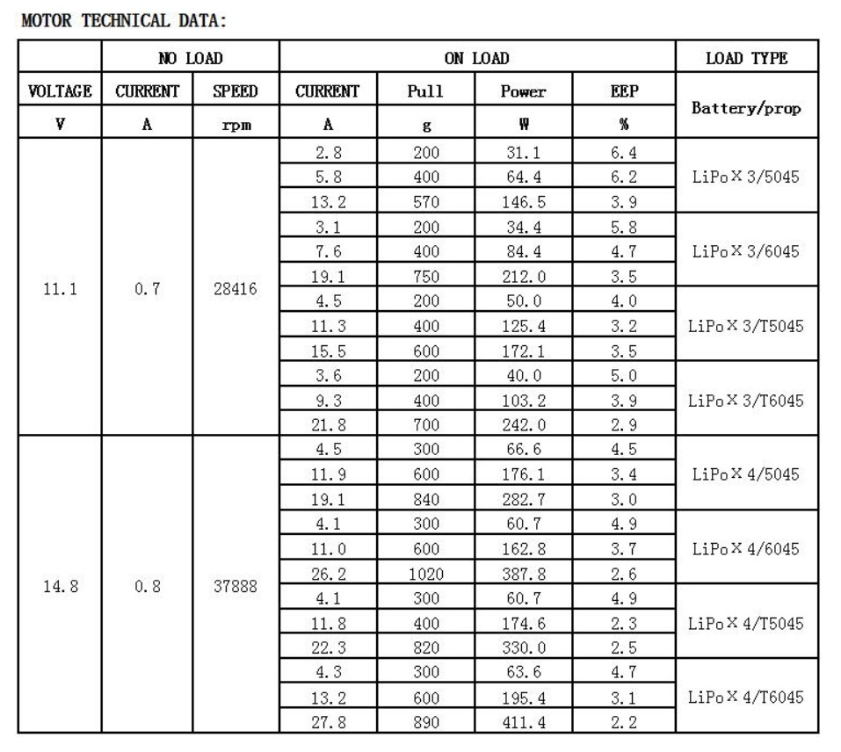

Taken from official website, link given below.

**Render:** 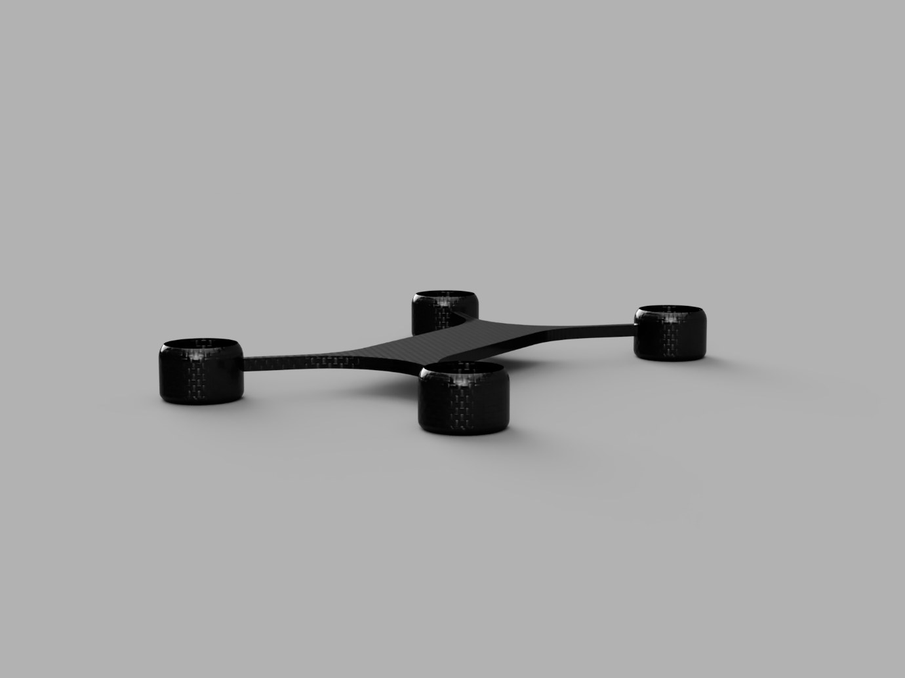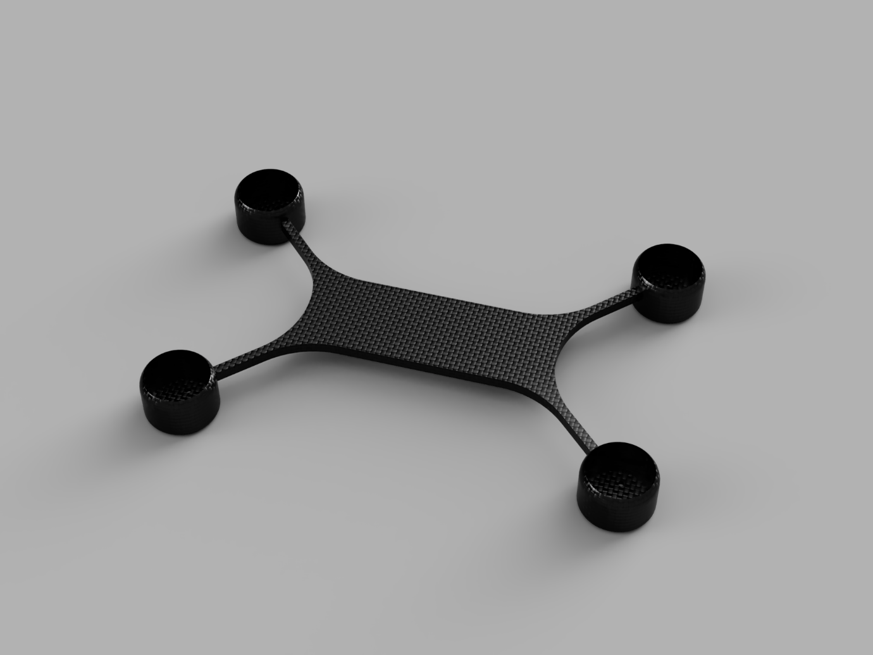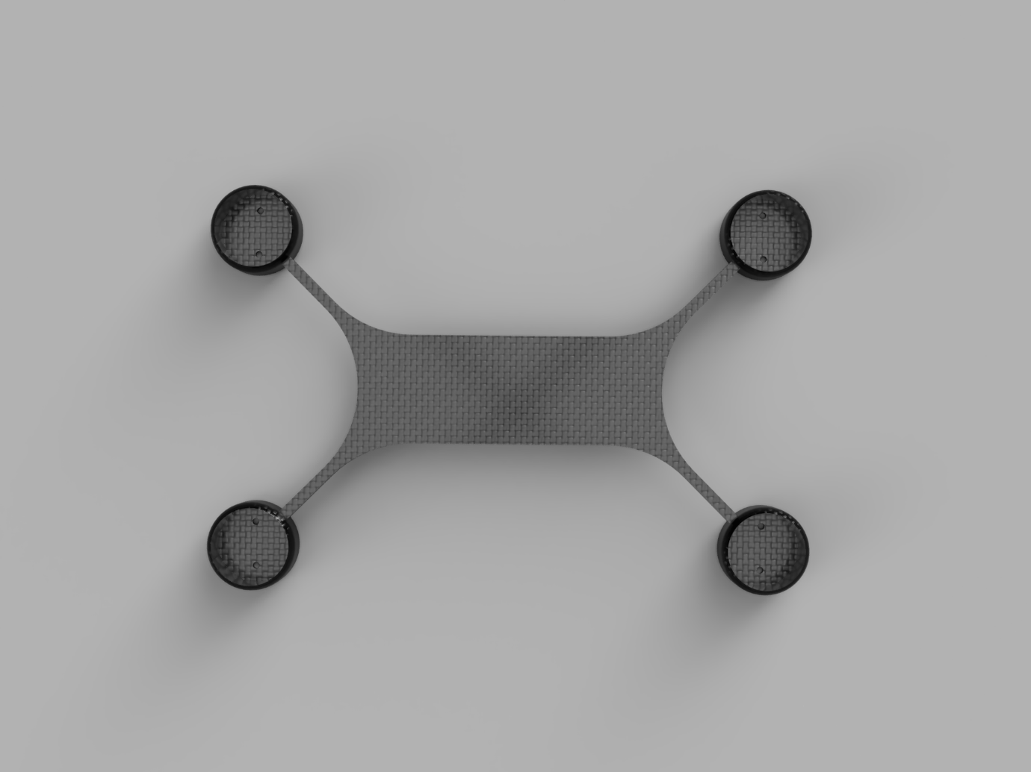

**Links:**

Motor/prop   
<https://fpv.tv/dys-motors-se2205-pro-series/>  
<http://www.dys.hk/product/SE2205%20PRO.html>  
Receiver  
<https://www.risingsunfpv.com.au/collections/receviers/products/tbs-crossfire-nano-rx>  
PDB  
<https://www.risingsunfpv.com.au/collections/pdb/products/matek-pdb-bec-5v-12v-pdb-xt60>  
Flight controller  
<https://www.risingsunfpv.com.au/collections/fc/products/brainfpv-radix-li-flight-controller>  
ESC  
<https://www.risingsunfpv.com.au/collections/escs/products/spedix-gs30-30a-2-4s-32bit-dshot-1200-esc>  
Battery  
<https://www.amazon.com/TATTU-2300mAh-Battery-Racing-Drones/dp/B013I9SVD2#HLCXComparisonWidget_feature_div>